# EMBEDDED SYSTEM DESIGN LAB ASSIGNMENT -6

**IMPLEMENTATION OF**

**SERIAL PERIPHERAL INTERFACE (SPI)**

**FOR LPC2148 MICROCONTROLLER**

**SUBMITTED BY- SANCHIT AGRAWAL (2016H140106) ABHINAV GARG (2016H140103)**

# Objective –

Objective of this experiment is to learn and implement SPI (Serial Peripheral Interface) for LPC2148 microcontroller. LPC2148 microcontroller.

**To do-**

Send continuous data to 74HC595 from 0 - 255 with a delay of 1 second for between 2 consecutive values. 8 LEDs should display the count from 0-255 with 1 second interval between changing values.

System should repeat this task infinitely

# Overview

SPI is a Master - Slave protocol, one device acts as the bus master while any number of devices can act asslaves. SPI is a serial synchronous protocol that means all the data going in or out is synchronized by a clock. SPI device have separate lines for data out and data in.

All SPI based communication happens over 4 lines named MOSI, MISO, SCK, SS.

**MOSI** - Master Out Slave In (master device sends data over this line)

**MISO -** Master In Slave out (master device accepts data over this line)

**SCK -** Serial clock (generated by bus master)

**SS** - Slave select (Useful in the case of multiple slaves)

IC 74HC595 is a 8 bit serial to parallel data converter, it takes data-in over serial interface and latches that data in the 8 bit parallel output. 8 LEDs are connected to LPC2148 SPI output through 74595 in our experiment board.

# Project Workspace-

* Used keil u-vison5..
* Under ARM section, select the board as LPC 2148.

Include all the header files and the source files that are required for the program

* Workspace consists of all the library files.
* Then, after ARM programming, select the target device that is to be programmed and burn the bin file into the device.
* Provided inter chip communication using SPI, sending it to serial to parallel data converter(74HC595) and displaying it on LEDs present on the board.

**Critical Issues**

* SHCP should be triggered from ‘low’ to ‘high’ on every data transmission to 74HC595,
* Synchronization of data transmission with the clock.

**Register Description for SPI Communication: -**

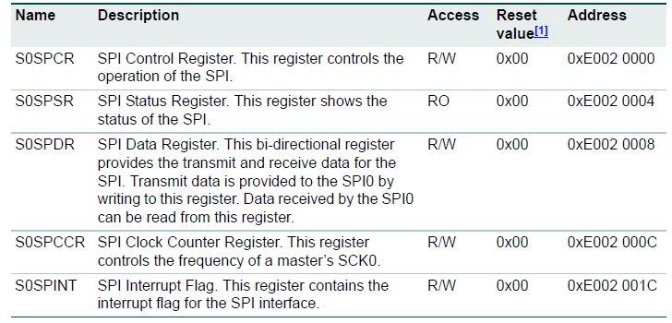

# Methodology –

* Out of SPI0 and SPI1 we selected SPI0 for implementation. SPI0 is operated in master mode, and IC 74HC595 which is a 8 bit serial to parallel data converter is selected as slave.
* Master clock frequency is prescaled by factor of 8.
* Port pin no.P0.7 is connected to SHCP and it acts as a internal clock such that in every clock pulse (i.e. pin status 0 to 1) data is latched on LED’s.
* Based on data latched and counters count, the count sequence from 0 to

255 is shown on the LED’s.

**Hardware Design** – Used LPC2148 board and all the required things such as LED’s and IC were present on board.

**SCHEMATIC**

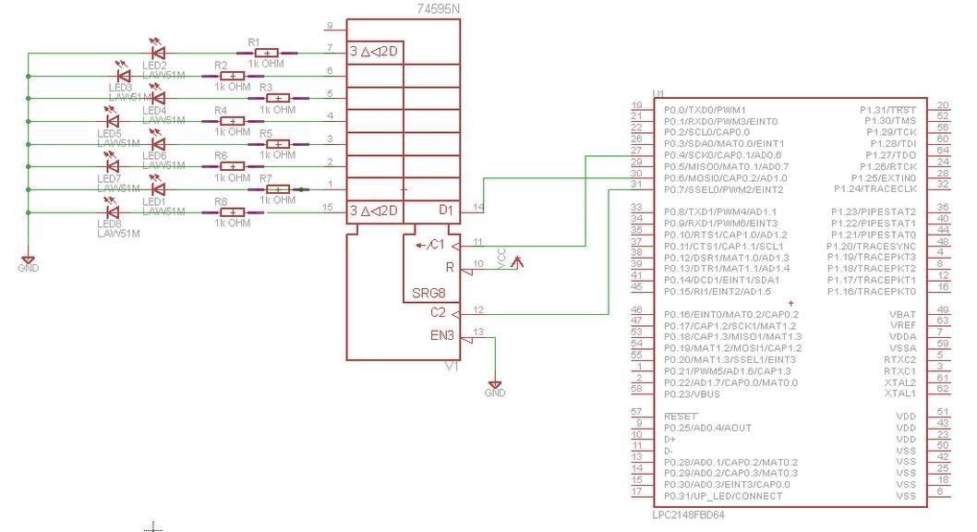

Figure above shows the schematic for the interfacing SPI using LPC2148

# FLOW CHART

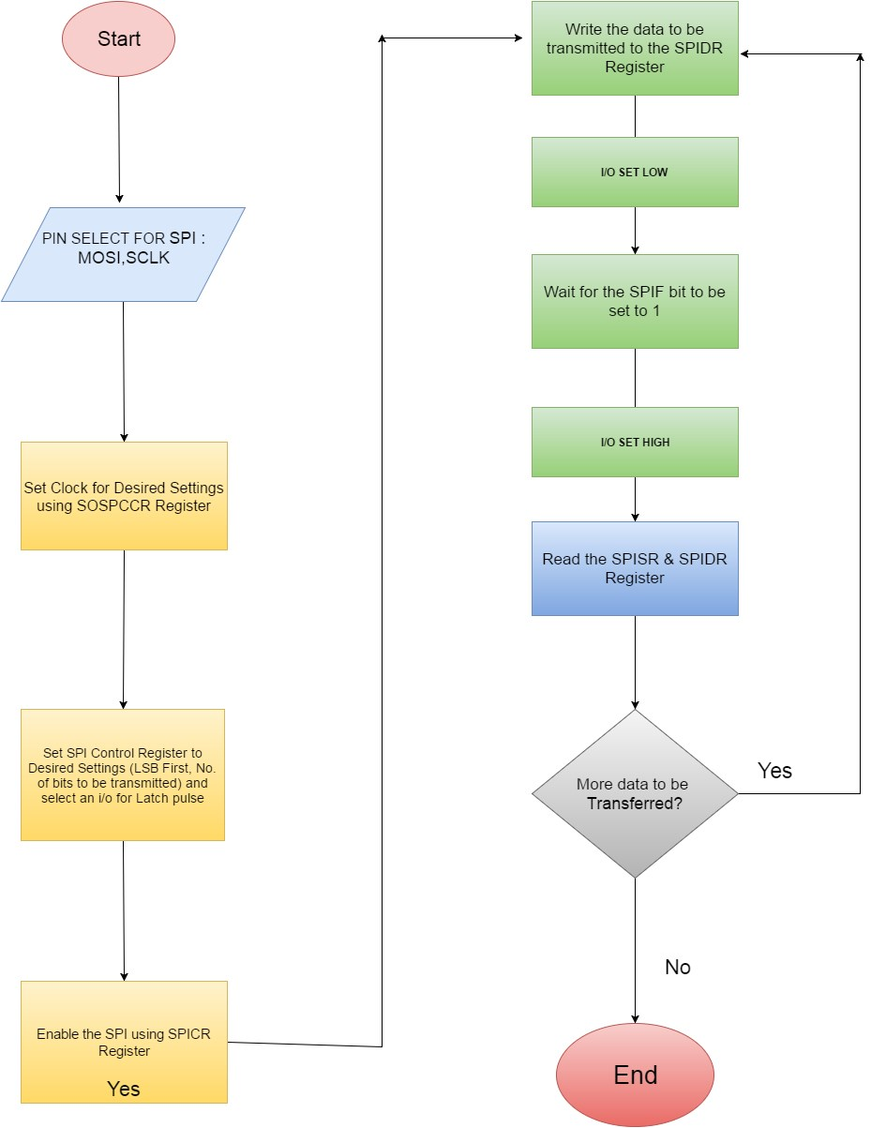

# Software Design –

Used Basic SPI initializing instructions to set it in master mode as well as for other configurations.

# Code Explanation –

* The Header file (LPC214x.h) includes all the input-output functions and their definitions.
* Functions such as delay and SPI initialisation wew declared after the header file.
* In SPI initialisation, SPI0 is configured and MOSI operation is selected. We connected SHCP to pin P0.7 by setting PINSEL0 to 0x00001100
* Master clock was prescaled by factor of 8 by setting S0SPCCR (clock prescaler control register ) to 8.
* SPI0 control register S0SPCR is set to 0x0860 so as to select master mode,

8 bit data stream, CPOH=0, CPOL=0

* SPI is enabled by writing 1 on 6th bit of S0SPCR (SPI control reg.)
* CPOH=0, CPOL=0 is set such that data is latched in the rising edge and transmitted on falling edge.
* Delay function is introduced so as to provide required delay between the counts.
* Connected port pin P0.7 to SHCP such as as soon as pin is set, data is latched to the LED’s.
* PB0 is configured as output port to latch STCP.
* Data to be transmitted is placed on S0SPDR (data reg.) and until that time SPIF bit of S0SPSR (status reg.) is 0
* Now, as soon as 8 bit stream is transmitted from TX buffer, SPIF bit becomes 1 and data is latched on LED’s by setting pin P0.7 .
* So following on the above steps, in accordance to the loop count from 0 to

255, respective values were shown with the help of data latched on LED’s.

The c code for the above is sent as an attachment for reference.

# Observation & Result –

Data was transmitted from SPI and latched successfully to LED’s.

The count sequence from 0 to 255 was successfully shown with the help of LED’s according to data latched.

**Conclusion**

Data was transmitted over the MOSI Pin to serial to Parallel converter and displayed as binary pattern on the LED.

# References-

LPC214x user manual.